***Create New Volume and Attach it to an EC2 Instance***

**Under EC2 click on EC2 dashboard. Select Volumes under Elastic Block Store and click on Create Volume**

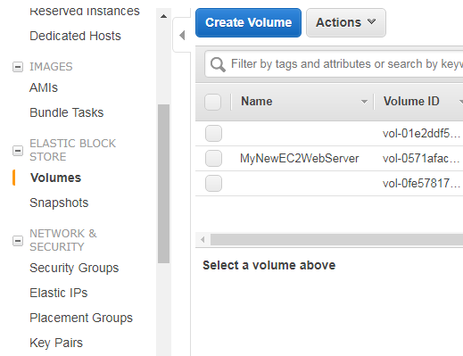

**Select volume type – General Purpose SSD, Size – 1GB, Your availability zone should be same where you launched your EC2 instance**

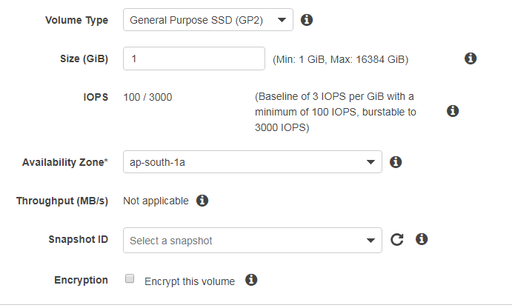

**Your Volume is created. Click on the Volume ID and you would be redirected to Volume Page**

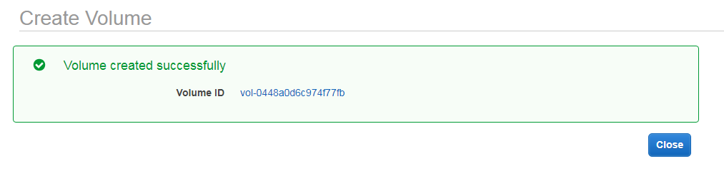

**Open Putty and give command lsblk. Your volume is not attached**

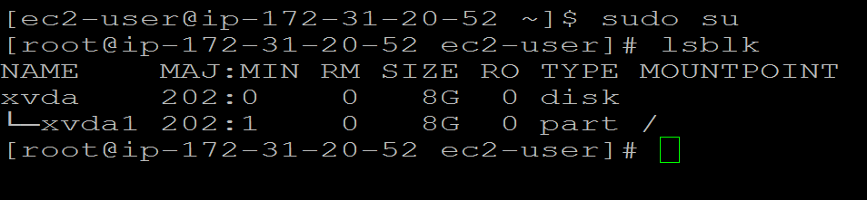

**In Volume page select your created volume. Click on Actions and select Attach Volume**

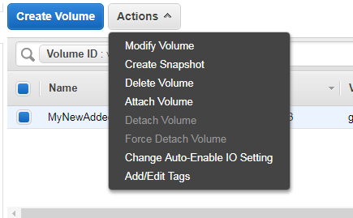

**Select the Instance in which you want your volume to be attached and click Attach**

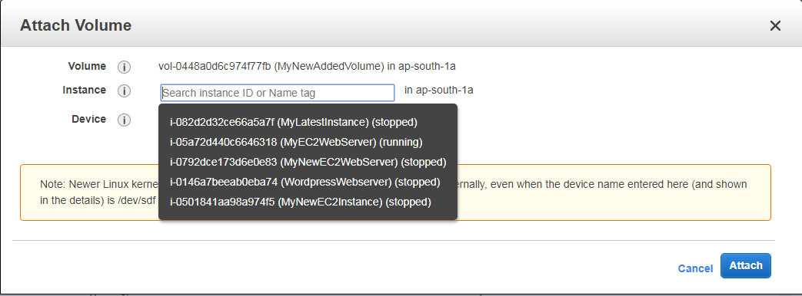

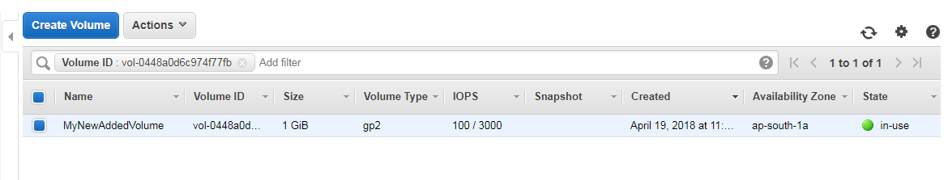

**Go to your putty and give lsblk to check if your volume is attached. Your New Volume of 1GB is attached to your machine**

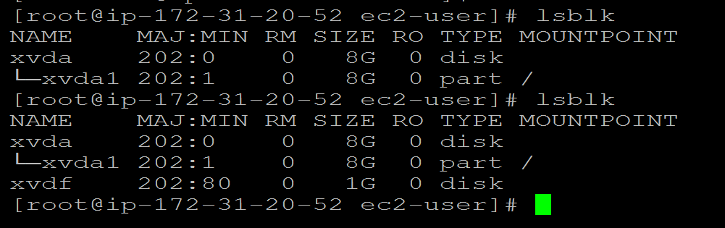

**Format and Mount your Volume**

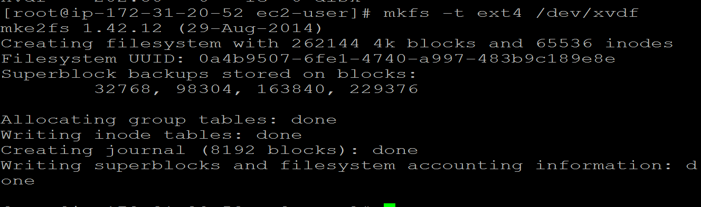**Create a directory and attach MyNewVolume**

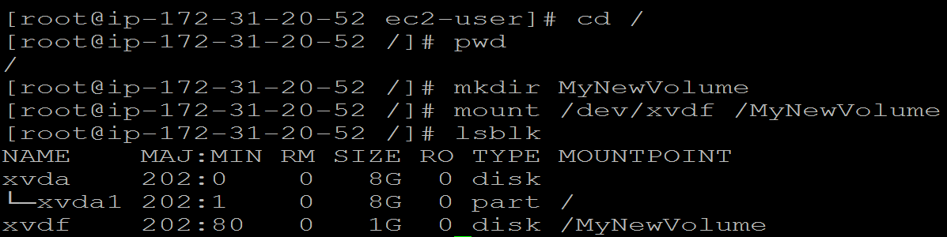

**Create a text document in your MyNewVolume**

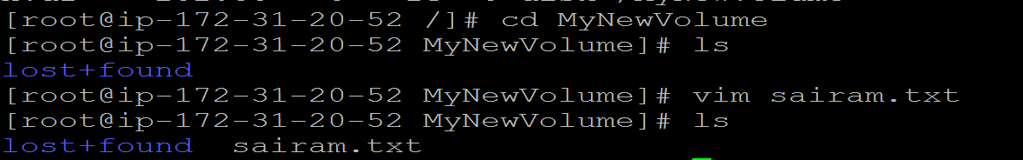

**Your document is now created in your MyNewVolume**

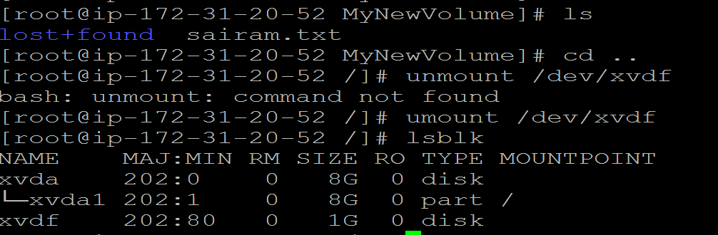

**Select your volume and under Actions click Detach Volume**

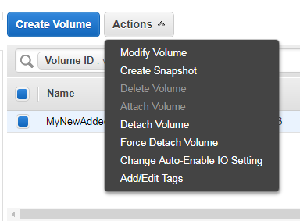

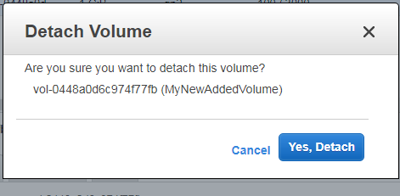

**Your Volume is detached but it is still available. You can attach it to some other instance if needed.**

